Game Design Document

Fill up the following document

1. Write the title of your project.

Mario Quiz Dash

1. What is the goal of the game?

1.Knowledge acquisition

2.Motivation

3.Entertainment

1. Write a brief story of your game.

I want to make a Quiz game for kids, So there is a challenge for me to make this game

Interesting then me and my father plan a game, we make a running game in this game one enemy is chasing the player and some obstacles block player’s way. To clear the

obstacles player answer some questions after solving all questions he reach the next

level and every week we update the questions.

1. Which are the playing characters of this game?

* Playing characters are the ones who respond to the user based on the input from the user.
* Cars, monkeys, dinos, wizards, etc., are the playing characters in the game.

|  |  |  |
| --- | --- | --- |
| Number | Character Name | What can this character do? |
| 1 | Super Mario | player |
| 2 |  |  |
| 3 |  |  |
| 4 |  |  |
| 5 |  |  |
| 6 |  |  |
| 7 |  |  |
| 8 |  |  |

1. Which are the Non-Playing Characters of this game?

* Non-Playing characters are the ones that don't have an action or behavior when the user interacts with the game.
* Hurdles, stones, bananas, coins, etc., are non-playing characters in the game.

|  |  |  |
| --- | --- | --- |
| Number | Character Name | What can this character do? |
| 1 | Browser | Chasing the player |
| 2 | Blooper | Block player’s way |
| 3 | Gomba | Block player’s way |
| 4 | Bull Wario | Block player’s way |
| 5 |  |  |
| 6 |  |  |
| 7 |  |  |
| 8 |  |  |

Draw your imagination of this game. What does this game look like?

* Draw the game either on your computer or on paper.
* Add images of the game scenes to show each of the playing and non-playing characters at least once.

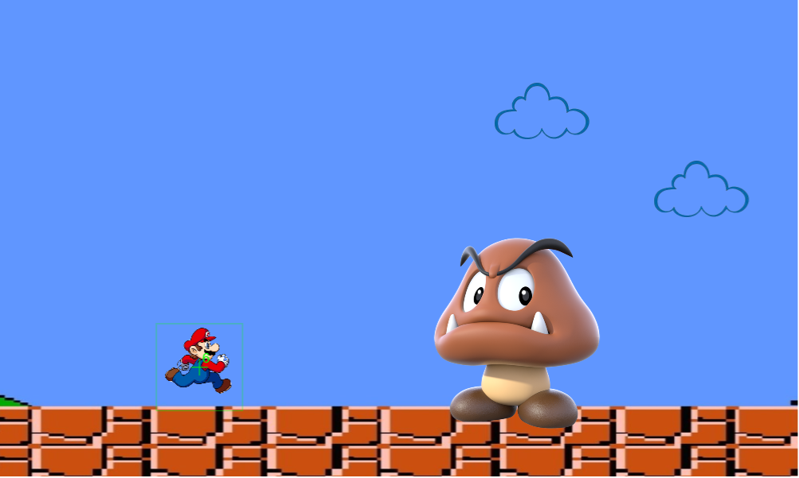

How do you plan to make your game engaging?

I am making a quiz game, and mostly quiz games have only questions, but I am making

a running quiz game in this quiz game we have a running game also, in my game some

obstacles come and ask questions and the player answer the questions.